**IslamXplorer**

|  |
| --- |

**By:**

**Ahmad Hassan**

**23324**

**Supervised by:**

**Shahid Ali Khan**

**Faculty of Computing**

**Riphah International University, Islamabad**

**Spring/Fall 2023**

**A Dissertation Submitted To**

**Faculty of Computing,**

**Riphah International University, Islamabad**

**As a Partial Fulfillment of the Requirement for the Award of the Degree of**

**Bachelors of Science in Computer Science**

**Faculty of Computing**

**Riphah International University, Islamabad**

Date: [date of final presentation]

**Final Approval**

This is to certify that we have read the report submitted by ***Ahmad Hassan (23324)***, for the partial fulfillment of the requirements for the degree of the Bachelors of Science in Computer Science (BSCS). It is our judgment that this report is of sufficient standard to warrant its acceptance by Riphah International University, Islamabad for the degree of Bachelors of Science in Computer Science(BSCS).

**Committee:**

| **1** | Mr. Shahid Ali Khan  (Supervisor) |
| --- | --- |
|  |  |
| **2** | Dr. Musharraf  (Head of Department/chairman) |

**Declaration**

We hereby declare that this document “**IslamXplorer]**” neither as a whole nor as a part has been copied out from any source. It is further declared that we have done this project with the accompanied report entirely on the basis of our personal efforts, under the proficient guidance of our teachers especially our supervisor **Mr. Shahid Ali Khan**. If any part of the system is proved to be copied out from any source or found to be reproduction of any project from anywhere else, we shall stand by the consequences.

**___________________________**

**Ahmad Hassan**

**23324**

**Dedication**

Insert dedication here…

**Acknowledgement**

First of all we are obliged to Allah Almighty the Merciful, the Beneficent and the source of all Knowledge, for granting us the courage and knowledge to complete this Project.

[Students will acknowledge here anyone who has helped in the project. It can include Supervisor(s), Teachers, Class mates, Friends and Family]

**___________________________**

**Ahmad Hassan**

**23324**

**Abstract**

This report provides a detailed exploration of the Islamic Knowledge Search Engine app, with a primary focus on the implementation and significance of the Knowledge Graph using Neo4j. It begins by introducing the motivation behind the app, addressing the challenges associated with navigating Islamic knowledge. The Requirements Engineering section delves into the systematic process of identifying user needs, emphasizing the integral role of the Knowledge Graph in structuring and interconnecting Quranic verses, Hadiths, and related concepts. The subsequent chapters highlight the pivotal role of the Knowledge Graph in fostering a deeper understanding of Islamic teachings. The report concludes by summarizing the unique contributions of the Knowledge Graph, underlining its significance in creating a cohesive and context-rich platform for users exploring the intricate web of Islamic knowledge.

**Table of Contents**

| List of Figures | 1 |
| --- | --- |
| List of Tables | 2 |
| Chapter 1: Introduction | 3 |
| * 1. Opportunity & Stakeholders | 4 |
| * 1. Motivations and Challenges | 5 |
| * 1. Goals and Objectives | 6 |
| * 1. Solution Overview |  |
| * 1. Report Outline |  |
| Chapter 2: Literature / Market Survey |  |
| 2.1 Introduction |  |
| 2.2 Literature Review/Technologies Overview |  |
| 2.3 Summary |  |
| Chapter 3: Requirement Engineering |  |
| 3.1 Introduction |  |
| 3.2 Problem Scenarios |  |
| 3.3 Functional Requirements |  |
| 3.4 Non-Functional Requirements  3.5 SQA activities: Defect Detection  3.5.1 Test Case Design |  |
| Chapter 4: System Design |  |
| 4.1 Introduction |  |
| 4.2 Architectural Design |  |
| 4.3 Detailed Design  4.4 SQA activities: Defect Detection  4.4.1 Test Case Design |  |
| Chapter 5: Implementation |  |
| 5.1 Endeavour (Team + Work + Way of Working) |  |
| 5.2 Flow Control/Pseudo codes |  |
| 5.3 Components, Libraries, Web Services and stubs  5.4 IDE, Tools and Technologies |  |
| 5.5 Best Practices / Coding Standards  5.5.1 Software Engineering Practices  5.5.2 Development Practices & Standards |  |
| 5.6 Deployment Environment  5.7 SQA activities: Defect Detection  5.7.1 Test Case Design (White box) |  |
| 5.8 Summary |  |
| Chapter 7: Conclusion and Outlook |  |
| 7.1 Introduction |  |
| 7.2 Achievements and Improvements |  |
| 7.3 Critical Review |  |
| 7.4 Future Recommendations/Outlook |  |
| 7.5 Summary |  |
| References |  |
| Appendices |  |
| Appendix-A: Software Requirements Specifications (SRS) |  |
| Appendix-B: Design Documents |  |
| Appendix-C: Coding Standards/Conventions |  |
| Appendix-D: Test Scenarios |  |
| Appendix-E: Work Breakdown Structure |  |
| Appendix-F: Roles & Responsibility Matrix |  |

**List of Figures**

| 1.1 Caption of first figure of first chapter | 6 |
| --- | --- |
| 1.2 Caption of second figure of first chapter | 7 |
| 2.1 Caption of first figure of second chapter | 14 |
| 2.2 Caption of second figure of second chapter | 22 |
| 2.3 Caption of third figure of second chapter | 26 |
| 5.1 Caption of first figure of fifth chapter | 49 |
| 5.2 Caption of second figure of fifth chapter | 49 |

**List of Tables**

| 1.1 label of first table of first chapter | 6 |
| --- | --- |
| 1.2 label of second table of first chapter | 7 |
| 2.1 label of first table of second chapter | 14 |
| 2.2 label of second table of second chapter | 22 |
| 2.3 label of third table of second chapter | 26 |
| 5.1 label of first table of fifth chapter | 49 |
| 5.2 label of second table of fifth chapter | 49 |

**Chapter 1:**

**Introduction**

**Chapter 1:**

**Introduction**

IslamXplorer, a sophisticated mobile application meticulously crafted to enrich your connection with Islam. More than just a tool, IslamXplorer serves as your comprehensive companion, seamlessly integrating essential features to enhance your daily practices and foster a deeper understanding of Islamic principles.

At the heart of IslamXplorer lies a powerful Knowledge Graph, meticulously curated to provide a nuanced exploration of Islamic concepts. This dynamic graph includes nodes for fundamental pillars like Zakat, Salat, Pilgrimage, Tawheed, and Fasting. Complementing these are Concept nodes, delving into topics such as Punishments, Rewards, and Exceptions. Each node is intricately connected to relevant Quranic verses and Hadiths, ensuring a rich and interconnected tapestry of knowledge.

* 1. **Opportunity & Stakeholders**

In the realm of Islamic Apps, a search engine can help people find information about Islam from a variety of sources, including the Quran, the Hadith, and scholarly works. This can be a valuable resource for people who are new to Islam or who are looking for more information about a particular topic. A Knowledge Graph also helps in preserving the Islamic heritage by making it making everything digitalised, storing everything in an interconnected manner, that captures the true essence of the Islamic texts

**1.1.1 Opportunity**

* **Educational Resource:** This project can serve as a valuable educational resource for individuals seeking to study the Quran and Hadith, scholars, students, and the general public.
* **Research Aid:** It can aid researchers and scholars in analyzing and extracting valuable insights from Islamic texts more efficiently.
* **Interfaith Dialogue:** The project can facilitate interfaith dialogue by providing accessible information about Islamic teachings.
* **Content Accessibility:** It can make Quranic and Hadith content easily accessible to a global audience.

**1.1.2 Stakeholders**

***Knowledge Seekers***

* **Muslim Community:**

This is your primary user base, consisting of individuals who may be using your application for a variety of purposes, including personal learning, spiritual growth, or research. Catering to the needs of this group is crucial.

* **Experts, Scholars, Researchers:**

Access to authentic and reliable Islamic texts is essential for scholars and researchers in the field of Islamic studies. Providing them with a resource for in-depth research and analysis is a valuable service.

* **Institutions:**

Schools, universities, and Islamic educational institutions often require quality resources for teaching Islamic studies. Your application could become a valuable tool for educators and students alike.

* 1. **Motivations and Challenges**

IslamXplorer is an Islamic search engine app that uses a Knowledge Graph to provide users with access to authentic and reliable Islamic knowledge. The app is motivated by the goal of enriching the spiritual journey of its users, disseminating authentic Islamic knowledge, facilitating daily Islamic practices, and adapting to technological advancements.

Some of the challenges that IslamXplorer faces include ensuring the accuracy and authenticity of its content, encouraging consistent user engagement and education, and adapting to the ever-changing landscape of Islamic knowledge.

**1.2.1 Motivations**

* **Spiritual Enrichment:**

IslamXplorer is motivated by the profound goal of enriching the spiritual journey of its users. It aims to provide a comprehensive platform where individuals can deepen their understanding of Islamic principles, fostering a closer connection to their faith.

* **Knowledge Dissemination:**

The app is driven by the desire to disseminate authentic Islamic knowledge. By incorporating a robust Knowledge Graph that includes Quranic verses, Hadiths, and insights into various Islamic concepts, IslamXplorer aims to serve as a reliable source of information for users seeking to expand their understanding of Islam.

* **Facilitating Daily Practices:**

IslamXplorer is designed to facilitate and enhance daily Islamic practices. The inclusion of features such as Qibla direction, Masjid finder, and prayer times aims to make it easier for users to incorporate religious obligations into their daily routines, fostering a more mindful and organized approach to worship.

* **Adapting to Technological Advancements:**

Motivated by the rapid advancements in technology, IslamXplorer seeks to leverage these innovations to make Islamic knowledge more accessible and engaging. By embracing mobile technology, the app aims to reach a global audience, transcending geographical boundaries and cultural differences.

**1.2.2 Challenges**

* **Content Accuracy and Authenticity:**

Ensuring the accuracy and authenticity of the content within IslamXplorer poses a significant challenge. The app must carefully curate and verify Quranic verses, Hadiths, and other information to provide users with reliable and trustworthy knowledge.

* **User Engagement and Education:**

Encouraging consistent user engagement and education presents a challenge. IslamXplorer must implement strategies to keep users actively involved, motivated, and informed, especially in a digital landscape where attention spans can be limited.

* **Effective Knowledge Graph Creation:**

At the heart of IslamXplorer lies an intricate and vast Knowledge Graph, that interconnects topics and concepts to various Verses and Hadiths. The graph needs to be created in a manner so that it remains open for adding further nodes in the future, and it should capture the semantic relations between different topics through relationships in an effective manner.

* **Cultural Sensitivity and Inclusivity:**

IslamXplorer faces the challenge of being culturally sensitive and inclusive. The app must cater to a diverse global Muslim audience, considering variations in cultural practices, interpretations, and traditions.

* **Adaptation to User Feedback:**

Responding effectively to user feedback and evolving user needs is an ongoing challenge. IslamXplorer must have mechanisms in place to gather feedback, analyze it, and implement improvements to meet the dynamic expectations of its user base.

* 1. **Goals And Objectives**

The goals of creating an Islamic search engine app for Quran and Hadith that uses Knowledge Graphs are to Facilitate a profound spiritual journey for users by providing authentic Islamic knowledge,Serve as a reliable and accessible platform for the dissemination of accurate and authentic Islamic knowledge,Facilitate and enhance daily Islamic practices by providing tools such as Qibla direction, Masjid finder, and prayer times,Build a comprehensive corpus of Islamic teachings and values based on themes, concepts and topics, Embrace technological advancements to make Islamic knowledge more accessible and engaging.

**1.3.1 Goals**

1. **Spiritual Empowerment:**

Facilitate a profound spiritual journey for users by providing authentic Islamic knowledge, fostering a deep connection to faith, and empowering individuals to lead a more purposeful and spiritually enriched life, by providing options at the fingertips of the user

1. **Knowledge Dissemination:**

Serve as a reliable and accessible platform for the dissemination of accurate and authentic Islamic knowledge, making essential teachings, Quranic verses, and Hadiths easily accessible to a global audience.

1. **Enhanced Daily Practices:**

Facilitate and enhance daily Islamic practices by providing tools such as Qibla direction, Masjid finder, and prayer times, enabling users to seamlessly incorporate religious obligations into their routines.

1. **Islamic Knowledge Corpus:**

To build a comprehensive corpus of Islamic teachings and values based on themes, concepts and topics, that would allow storing of verses, hadiths, and other Islamic texts in a new and digitalised manner. An Islamic Knowledge Graph would incorporate semantic details, allowing for effective results based on query

1. **Technological Innovation:**

Embrace technological advancements to make Islamic knowledge more accessible and engaging. Leverage mobile technology to reach a diverse global audience, transcending geographical boundaries and cultural differences.

**1.3.1 Objectives**

1. **Curate a Comprehensive Knowledge Graph:**

Develop and maintain a dynamic Knowledge Graph that encompasses key Islamic concepts, principles, and teachings. Ensure the inclusion of authentic Quranic verses and Hadiths, creating a robust repository for users to explore and understand.

1. **Provide Users with tools to Enhance their Daily Practices:**

Offer users an accurate and reliable Qibla direction feature, utilizing device sensors to guide them towards the Kaaba in Mecca. Ensure a visually intuitive interface that aids users in aligning their prayers with precision.Develop a Masjid finder feature that enables users to locate nearby mosques effortlessly. Include essential details such as addresses, contact information, prayer times, and additional facilities, fostering a sense of community engagement.

1. **Implement Responsive and User-Friendly Design:**

Design an intuitive and responsive user interface that adapts to various devices and screen sizes. Prioritize user experience to ensure that IslamXplorer is accessible and user-friendly for individuals with diverse technological backgrounds.

1. **Encourage Active User Engagement:**

Implement strategies to encourage active user engagement through regular updates, informative content, and interactive features. Foster a sense of belonging and community among users to enhance their overall experience.

1. **Adapt and Grow Based on User Feedback:**

Establish mechanisms for gathering user feedback and insights. Analyze feedback to identify areas for improvement, innovation, and adaptation, ensuring that IslamXplorer evolves in response to the dynamic needs and expectations of its user base.

* 1. **Solution Overview**

Knowledge graphs excel in capturing semantic relationships between entities. They use nodes (entities) and edges (relationships) to connect data points. This makes them ideal for representing Quranic verses, and Hadiths, which are often interconnected in complex ways, and also, in turn, by providing a way to explore the intricate relationships between them.

Knowledge graphs are also inherently flexible. We can easily add new entities or relationships as our dataset expands, or it can be connected with other large datasets. This is advantageous as we are dealing with a diverse and intricate Islamic textual data, that needs to be continuously updated and enhanced. They can be used to identify and visualize the relationships between different Quranic verses and Hadiths. This can help users to understand the context of verses and Hadiths, and to see how they fit together in the overall body of Islamic teachings.

Knowledge graphs enable users to explore content within a contextual framework. Users can navigate between Quranic verses, and Hadiths seamlessly, as they are inherently connected. This allows users to gain a deeper understanding of the relationships between different Islamic concepts and how they fit together in the overall picture. They can be used to develop new research tools for scholars of the Quran and Hadith. For example, knowledge graphs could be used to identify patterns and trends in the Quran and Hadith, or to develop new hypotheses about the meaning and interpretation of verses and Hadiths.

* 1. **Report Outline**

**1.5.1 Chapter 1:**

This chapter introduces the concept of a search system and its importance in the modern world. It outlines the objectives of the project and the methodology that will be used to develop the search system.

**1.5.2 Chapter 2:**

This chapter surveys the existing literature on search systems and identifies the key features and functionalities that are essential for a successful search system. It also analyzes the market for search systems and identifies the target audience for the proposed system.

**1.5.3 Chapter 3:**

This chapter elicits and analyzes the requirements for the search system from stakeholders. It identifies the functional and non-functional requirements of the system and documents them in a clear and concise manner.

**1.5.4 Chapter 4:**

This chapter designs the architecture of the search system and describes the components of the system and their interactions. It also designs the data model for the system and the algorithms that will be used to index and search the data.

**1.5.5 Chapter 5:**

This chapter implements the search system according to the design specifications. It develops the software components of the system and integrates them into a working system.

**1.5.6 Chapter 6:**

This chapter outlines the comprehensive testing strategy for the search system. It includes unit testing, integration testing, system testing, and user acceptance testing to ensure the system meets the specified requirements and functions as intended. It also sees the testing of the Knowledge Graph with various Test Scenarious (and Use Cases)

**1.5.7 Chapter 7:**

This chapter summarizes the findings of the project and discusses the future work that could be done to improve the search system. It also reflects on the lessons learned from the project and provides recommendations for future projects.

**Chapter 2:**

**Literature/ Market Survey**

**Chapter 2:**

**Literature/ Markey Survey**

2.1 **Introduction**

IslamXplorer is an Islamic search engine application that uses knowledge graphs to provide users with a comprehensive and interactive way to explore the Quran and Hadith. The application is designed to be user-friendly and accessible to individuals with diverse technological backgrounds. It features a variety of features that make it an ideal tool for learning about Islam, including:

* A comprehensive database of Quranic verses and Hadiths
* A powerful search engine that allows users to search for specific content
* A knowledge graph that visualizes the relationships between different Quranic verses and Hadiths
* Interactive features that allow users to explore content in a variety of ways

The IslamXplorer application has the potential to be a valuable resource for Muslims and non-Muslims alike. It can be used to learn about Islam, to explore the relationships between different Quranic verses and Hadiths, and to engage in interactive learning experiences. The application is still under development, but it has already made significant progress. With continued development, IslamXplorer has the potential to become a leading Islamic search engine application.

**2.1.1 Problem Ellaboration**

Current platforms offer Quranic texts, Hadith collections, and other related material in isolation, making it difficult for users to establish meaningful connections between them. This fragmentation hinders comprehensive understanding of Islamic teachings. Representing the complex semantic relationships between Quranic verses, Hadiths, and other entities in a traditional database is challenging.

While various resources exist for Islamic studies, they are often scattered across books, websites, and libraries. This makes it difficult for users to find the information they need efficiently and effectively. There is a need for a centralized and comprehensive platform to access these resources, which would make it easier for users to learn about Islam.

Conventional search engines do not cater to the unique challenges of Quranic and Hadith study. Quranic verses and Hadiths are often interconnected, and users may need to be able to search for content based on these relationships. Additionally, Quranic and Hadith verses may have multiple meanings, and users may need to be able to search for content based on different interpretations.

As a result of these challenges, users often face difficulties in conducting precise, context-aware searches for Islamic knowledge. This can lead to inadequate exploration of the material and a limited understanding of Islamic teachings.

2.2 **Literature Review/ Technologies Overview**

The literature review and market survey for the Islamic Knowledge Search Engine app provide a comprehensive exploration of existing works and market dynamics relevant to the app's domain. The literature review delves into scholarly articles, research papers, and publications that discuss the representation and structuring of Islamic knowledge in digital environments. This includes studies on knowledge graphs, data modeling, and information retrieval specific to Quranic verses, Hadiths, and related concepts. Scholars may offer insights into the challenges and opportunities of leveraging technology to enhance the understanding of Islamic teachings.

2.2.1 Literature Review

The literature surrounding the Islamic Knowledge Search Engine app encompasses a rich landscape of scholarly works, technical documentation, and user-oriented resources. Scholarly literature explores the intricacies of Islamic knowledge representation, including Quranic verses, Hadiths, and their interconnections, often delving into the use of knowledge graphs for a more comprehensive understanding. Research articles may discuss the challenges of structuring and organizing Islamic knowledge in digital environments, shedding light on innovative approaches and methodologies.

2.2.1.1 **Summary of Al-Quran Ontology Based On Knowledge Themes by A. Ta'a, Q. A. Abed, and M. Ahmad**

The paper "AL-QURAN ONTOLOGY BASED ON KNOWLEDGE THEMES" by A. Ta'a, Q. A. Abed, and M. Ahmad presents a new approach to developing an ontology for the Quran based on knowledge themes. The authors argue that traditional ontology approaches are not well-suited for representing the complex and interconnected knowledge contained in the Quran. Instead, they propose a new approach that organizes the Quran's knowledge into a set of interrelated themes. The authors begin by identifying a set of 10 knowledge themes in the Quran:

1. Tawheed,
2. Risalah,
3. Akhirah,
4. Akhlaq,
5. Aqidah,
6. Ibadah,
7. Muamalah,
8. Tarikh
9. Qasas
10. Ayat.

They then define a set of sub-themes for each knowledge theme. For example, the sub-themes for the Tawheed knowledge theme include the **oneness of Allah**, **the attributes of Allah**, and **the names of Allah**. Once the knowledge themes and sub-themes have been identified, the authors develop an ontology that represents the relationships between the different concepts. The ontology is developed using the Web Ontology Language (OWL), which is a standard language for representing ontologies on the web.

The authors evaluate the ontology by conducting a series of experiments. The experiments show that the ontology can be used to effectively retrieve and classify Quranic knowledge. The authors also conclude that the ontology can be used to develop new applications for the Quran, such as intelligent search engines and question answering systems.

The authors have developed an ontology that represents the relationships between the different concepts in the Quran. These ontologies can be used as a model for developing our own ontologies for the Quran and Hadith

The research of these ontologies is still under development. The authors have focused on developing the ontology for the Tawheed knowledge theme, and they have not yet completed have not yet been integrated with a natural language processing (NLP) system. This means that users cannot yet query the ontology using natural language.

Overall, this research paper presents a valuable contribution to the field of Quranic knowledge representation. The authors' ontology is based on the concept of knowledge themes, which is a novel and effective approach for representing Quranic knowledge. We will use this research to carve our own Knowledge Graph by implementing the authors' ontologies and also by adding NLP capabilities.

2.2.1.2 **An experience of developing Quran ontology with contextual information support Rizwan Iqbal and Aida Mustapha**

This research paper presents an experience of developing a Quran ontology with contextual information support. The authors argue that existing Quran ontologies are limited in scope and knowledge, and that they do not support contextual information that is considered necessary for the correct interpretation of Quranic verses. The authors propose a new Quran ontology that encapsulates contextual information support, such as translations, revelation places, tafsir, and hadiths. The ontology was developed using a methodology merging approach, which made the ontology development more effective and intuitive. The authors evaluated the developed ontology and found that it satisfied the requirements specification. They also found that the ontology can be reused and further enhanced to support many Quran-related semantic applications in the future.

One of the most relevant aspects of this research paper for your project is the authors' focus on developing an ontology that supports the contextual interpretation of Quranic verses. This is an important consideration for any Quran ontology, as it allows users to better understand the meaning of the Quran in light of its historical and religious context.

The ontology includes a number of features that support contextual information, such as:

● **Revelation context:** The ontology includes information about the revelation context of each verse, such as the time and place of revelation.

● **Tafsir:** The ontology includes links to tafsir, which are commentaries on the Quran.

● **Hadith:** The ontology includes links to hadith, which are the sayings and actions of the Prophet Muhammad.

Another relevant aspect is the authors' use of a methodology merging approach to develop the ontology. This approach allows the authors to take advantage of the strengths of both top-down and bottom-up ontology development.

One limitation of this research paper is that it does not provide a detailed description of the ontology's classes and properties. This means that you will need to read the paper carefully to understand how the ontology is structured and how it can be used.

Overall, this research paper presents a valuable contribution to the field of Quran ontology development. The authors' ontology includes additional classes and properties to represent contextual information, which is an important consideration for any Quran ontology. We can use the research in this paper to improve your Knowledge Graph by implementing the authors' methodology merging approach and adding classes and properties to represent contextual information.

2.2.1.3 **Towards a Joint Ontology of Quran and Hadith Shatha Altammami, Eric Atwell, Ammar Alsalka**

This research paper presents the idea of a joint ontology of the Quran and Hadith. The authors argue that such an ontology would be a valuable resource for scholars and researchers, as it would allow for the integration of knowledge from the two primary sources of Islamic law.

The authors also discuss the challenges involved in developing a joint ontology, such as the need to reconcile differences in terminology and interpretation. However, they believe that these challenges are surmountable, and that the benefits of a joint ontology would outweigh the costs.

The authors propose a new ontology that is based on the following principles:

● **Comprehensiveness:** The ontology should cover all of the major concepts and relationships in the Quran and Hadith.

● **Accuracy:** The ontology should be accurate and up-to-date.

● **Flexibility:** The ontology should be flexible enough to support different types of applications.

● **Interoperability:** The ontology should be interoperable with existing Quran and Hadith ontologies.

The authors developed the ontology using a methodology that involved the following steps:

1. **Identify the core concepts and relationships in the Quran and Hadith.**
2. **Define classes and properties to represent the core concepts and relationships.**
3. **Populate the ontology with data from the Quran and Hadith.**
4. **Evaluate the ontology for accuracy, completeness, and consistency.**

The ontology includes a number of features that support interoperability, such as:

● **Unique identifiers for all classes and properties.**

● **Links to existing Quran and Hadith ontologies.**

● **Use of standard ontological vocabularies.**

One of the most relevant aspects of this research paper is the authors' focus on developing a joint ontology of the Quran and Hadith. This is essential, as it will allow us to create a Knowledge Graph that represents the full range of Islamic knowledge. Another relevant aspect is the authors' methodology for developing the ontology. This methodology is well-defined and comprehensive, and it can be very well be used (or take reference from the principles) to develop our own ontologies.

One limitation of this research paper is that it does not provide any implementation details for the ontology. It does provides the principles that need to be taken care, and the steps taht need to be followed. It also provides with certain examples from the Quran and Hadith, for the identification of different concepts and how they are interlinked. But it does not go into dept so as to make an ontology from the provided details.

2.2.1.4 **Statistical Parsing by Machine Learning from a Classical Arabic Treebank Kais Dukes**

The research paper "Statistical Parsing by Machine Learning from a Classical Arabic Treebank" by Kais Dukes presents a novel approach to statistical parsing for Classical Arabic. Dukes argues that traditional statistical parsing methods are not well-suited for Classical Arabic due to its rich morphology and free word order.

Dukes proposes a new hybrid parsing approach that combines statistical methods with traditional Arabic grammatical knowledge. The approach is based on a new treebank of Classical Arabic sentences that has been manually annotated with grammatical information.

Dukes evaluated the proposed parsing approach on a held-out test set and achieved an F1-score of 89.03%. This is significantly higher than the performance of traditional statistical parsing methods on Classical Arabic.

One of the most relevant aspects of this research paper for your project is the author's proposed hybrid parsing approach. This approach combines the strengths of statistical methods with the strengths of traditional Arabic grammatical knowledge. This makes it well-suited for parsing Classical Arabic, which is a language with rich morphology and free word order.

● **Extract more accurate semantic information from the Quran and Hadith text.** Dukes' hybrid parsing approach can be used to extract the semantic meaning of sentences in Classical Arabic more accurately and reliably than traditional statistical parsing methods. This semantic information can then be used to populate your Knowledge Graph with more accurate and informative data.

● **Identify and extract concept nodes more accurately.** Dukes' treebank of Classical Arabic sentences is manually annotated with grammatical information, which makes it possible to identify and extract concept nodes from the Quran and Hadith text more accurately. This will help you to create a more comprehensive and informative Knowledge Graph.

One limitation is that Dukes' thesis does not explicitly address the issue of knowledge representation. Ontologies require a formal and explicit representation of concepts and relationships between concepts. Dukes' thesis does not provide a specific methodology or framework for representing knowledge in an ontological form.

Another limitation is that Dukes' thesis does not address the issue of ontology reasoning. Ontologies are used to support a variety of reasoning tasks, such as concept classification, query answering, and inference. Dukes' thesis does not provide any specific techniques for using statistical parsing to improve the performance of these reasoning tasks.

Overall, the research paper presents a valuable contribution to the field of Classical Arabic natural language processing. The author's proposed hybrid parsing approach is well-suited for parsing Classical Arabic, and the author's new treebank of Classical Arabic sentences is a valuable resource for developing and evaluating parsing algorithms for Classical Arabic. We can use the research in this paper to improve our project by integrating the proposed parsing approach into your Knowledge Graph pipeline and evaluating your Knowledge Graph on a variety of tasks.

2.2.1.5 **Summary**

| **Research Paper** | **Author(s)** | **Year** | **Themes** | **Tools** | **Limitations** |
| --- | --- | --- | --- | --- | --- |
| An experience of developing Quran ontology with contextual information support | Rizwan Iqbal  Aida Mustapha | 2013 | 5 Concepts (on the hierarchical Nature of Quran), with Tafsir | Protege | 1. It doesn’t handlethematic concepts/ topics 2. Hierarchical Nature of Hadith is not mentioned |
| Statistical Parsing by Machine Learning from a Classical Arabic Treebank | Kais Dukes | 2013 | 300 (Concepts from Quran) | XML  JQuranTree  LAMP | 1. It focuses more on Semantic Ontologies, than Concepts 2. It doesn’t provide proper attributes and relations between entities 3. It provides no mechanism for searching the ontologies |
| Al-Quran Ontology Based On Knowledge Themes | A. Ta'a  Q. A. Abed  M. Ahmad | 2017 | 10 Main Themes + 95 Sub Themes (from Quran) | OWL | 1. There are no certain principles followed for making ontologies 2. The ontologies refer only Quran 3. There is no Natural Language Query system |
| Towards a Joint Ontology of Quran and Hadith | Shatha Altammami  Eric Atwell  Ammar Alsalka | 2020 | No Topics  (Principles and Standards are mentioned for concept and topic extraction from Quran and Hadith) | Camel Tool  Wordnet | 1. It provides no implementation of ontologies 2. It provides no mechanism for searching the ontologies |

2.2.2 Market Survey

Existing Islamic apps and platforms, while useful, often come with several limitations and defects. Understanding these shortcomings can help you identify areas where your project can offer improvements. Here are some common defects in existing systems:

* **Limited Content Depth:** Many existing Islamic apps offer a limited selection of Quranic verses and hadiths. Users may not find comprehensive content or detailed explanations on various topics.
* **Lack of Contextual Understanding:** Some apps don't provide the necessary context for users to understand the significance and meaning of Quranic verses and hadiths. Context is crucial for interpreting and applying these texts correctly.
* **Scattered Information:** Information is often scattered across various sources and platforms, making it challenging for users to find all the relevant content in one place.
* **Search Limitations:** The search functionality in many apps may be basic and not optimized for advanced queries. Users may have trouble finding specific content or relevant information.
* **Scalability:** With the use of Traditional databases, existing apps are not much scalable as their content and data is fixed and static, making it impossible for them to grow as new researches are happening everyday.

2.2.2.1 **Islam360**

**Islam360** is a comprehensive Islamic application that caters to a wide range of users seeking Islamic knowledge and guidance. It offers a plethora of features, including:

* **The Quran:** Islam360 provides access to the Quran in Arabic script, accompanied by translations in English and other languages. This allows users to recite, study, and understand the Quran in their preferred language.
* **Hadith Collections:** The application houses a vast collection of hadith, the sayings and teachings of Prophet Muhammad (PBUH). Users can browse through various hadith collections, search for specific hadith, and gain insights into Islamic principles and practices.
* **Prayer Times:** Islam360 offers accurate prayer times based on the user's location. This helps Muslims stay informed about their prayer obligations and perform them at the correct time.
* **Dua (Supplications):** Islam360 features a collection of dua, supplications, and prayers that Muslims can recite for various occasions and needs. This helps users connect with their faith and seek guidance and blessings from Allah.
* **Articles and Videos on Islamic Topics:** Islam360 offers a wealth of articles and videos on various Islamic topics, covering a wide spectrum of Islamic knowledge, from Quranic interpretation to Islamic history and jurisprudence.
* **Community Forum:** The application provides a community forum where users can connect with fellow Muslims, ask questions, share experiences, and engage in discussions about Islam.

Islam360 stands out as a valuable resource for Muslims seeking to deepen their understanding of Islam and connect with their faith. Its comprehensive features, user-friendly interface, and active community make it a popular choice among Muslims worldwide.

While Islam360 shares similarities with IslamXplorer in providing Islamic information, it differs in its broader scope and more general-purpose nature. IslamXplorer is focused on building a knowledge graph of Islamic knowledge, a structured representation of Islamic information that can be used to answer questions, generate insights, and develop new applications.

Overall, Islam360 is a well-established and well-regarded Islamic application that caters to a wide range of users seeking Islamic knowledge and guidance. Its comprehensive features, user-friendly interface, and active community make it a popular choice among Muslims worldwide.

2.2.2.2 **Tarteel.ai**

**Tarteel.ai** is an innovative Islamic application that utilizes artificial intelligence (AI) to enhance the learning and recitation of the Quran. It offers a range of features, including:

* **Personalized Quran Recitation:** Tarteel.ai employs AI to provide real-time feedback on the user's pronunciation and tajweed (Quranic recitation rules). This personalized feedback helps users improve their recitation accuracy and fluency.
* **Interactive Quran Learning:** The application offers interactive learning modules that guide users through the Quran, providing explanations of Arabic grammar, vocabulary, and tafsir (Quranic exegesis).
* **Quran Memorization Assistance:** Tarteel.ai features tools to aid in Quran memorization, such as spaced repetition and customizable memorization plans.
* **Gamified Quran Engagement:** The application incorporates gamified elements, such as badges and rewards, to motivate users and make the learning process more engaging.
* **Multi-Lingual Support:** Tarteel.ai supports multiple languages, making it accessible to a wide range of users worldwide.

Tarteel.ai has garnered positive feedback from users, praising its innovative AI-powered features, user-friendly interface, and overall effectiveness in enhancing Quran learning and recitation. The application has been recognized for its contributions to Islamic education and has received several awards, including the "Best Islamic App" award at the World Islamic Apps Summit.

While Tarteel.ai shares similarities with IslamXplorer in promoting Quran learning and recitation, it differs in its focus on AI-powered personalized feedback and gamified engagement. IslamXplorer, on the other hand, aims to build a comprehensive knowledge graph of Islamic knowledge, encompassing not only the Quran but also hadith.

Overall, Tarteel.ai stands as a nouvelle approach in the emerging field of AI that can help Muslims, seeking to improve their Quran recitation and deepen their understanding of the Quran. Its innovative AI-powered features, user-friendly interface, and emphasis on personalized feedback make it a popular choice among Quran learners worldwide.

2.2.2.3 **Corpus.quran.com**

**Corpus.quran.com** is an extensive online resource dedicated to the Holy Quran, offering a multitude of features to aid in exploration, understanding, and memorization of the sacred text. It serves as a comprehensive repository of Quranic data, catering to individuals seeking to deepen their connection with the Quran and enhance their knowledge of Islam.

At the heart of Corpus.quran.com lies its vast collection of Quranic texts, available in Arabic script and accompanied by translations in over 100 languages. This extensive multilingual collection caters to a diverse global audience, making the Quran accessible to individuals from various linguistic backgrounds.

Corpus.quran.com is a website that provides a comprehensive resource for studying the Quran. It offers a variety of features, including:

* **Quranic Text:** The website provides the full text of the Quran in Arabic script, along with translations in over 100 languages.
* **Tajweed:** Corpus.quran.com offers tajweed tools to help users learn the proper recitation of the Quran. These tools include tajweed rules, recitation guides, and audio recordings of Quran recitations.
* **Arabic Grammar:** Corpus.quran.com offers Arabic grammar resources to help users understand the Arabic language of the Quran. These resources include grammar rules, vocabulary lists, and exercises.
* **Search Function:** The website has a powerful search function that allows users to search the Quranic text, tafsir, and Arabic grammar resources.

Corpus.quran.com is a valuable resource for Muslims seeking to deepen their understanding of the Quran. Its comprehensive features, user-friendly interface, and reliable sources make it a popular choice among Quran scholars and students worldwide. IslamXplorer, on the other hand, aims to build a comprehensive knowledge graph of Islamic knowledge, using Quran and Hadith, to provide thematic and topic-wise search capabilities.

Corpus.quran.com provides IslamXplorer with a wide array of resources to build its Knowledge Graph. It provides several ontologies that can be used to provide a base for the Graph. It also helps in understanding the Arabic verses for the identification of different topics and themes that the verse is discussing about. It also plays an important part to understand the hierarchy of topics mentioned in the Quran.

Overall, Corpus.quran.com stands as a valuable tool for Muslims seeking to study and understand the Quran. Its comprehensive features, user-friendly interface, and reliable sources make it a popular choice among Quran scholars and students worldwide.

2.2.2.4 **Google**

**Google** is the state of the art Search Engine used by billions of users. It uses Knowledge Graphs for the structuring of its data (including web pages, websites and web apps), by extracting concepts and keywords using Web Crawlers and Bots. These crawlers constantly check the content of the existing web pages and the new web pages, and link them using different relationships in its Knowledge Graph. It is a valuable resource for gathering vast amounts of information easily through searching.

Despite the vastness and depth of Google's Knowledge Graph, it is not Islam Oriented, meaning that in its core, it links different Islamic concepts based on the existing data of the web pages (written by all sorts of different people). Based on user search query, it provides different websites and web pages, making the user go through a myriad of knowledge. IslamXplorar addresses this issue to produce bite-sized information (i.e. specific verses and hadiths based on search query), that would allow the users to easily understand the concept that they are looking for.

2.2.2.5 **Quran.com & Sunnah.com**

Both **Quran.com** and **Sunnah.com** contain large amounts of Quranic data (All the Surahs and their verses in Arabic, and translations in various other languages) and Hadiths (Prominent books of Hadith like Sahih Bukhari, Sahih Muslim, etc. in Arabic and various other languages) respectively. They have vast amounts of data, digitalised, for easy access. They not only provide users with Quran learning, but also Arabic language learning, by providing users with word to word translations (with root syntax), and it provides explanations of Hadiths and Quranic Verses by offering Tafseers of different scholars. They can help users get better insights on the actual meaning and discussion of the concepts in the verses.

These resources provide users with several digitized Islamic sources, but they don't have the facility of searching incorporated in them. Despite the fact that they have such large databases, they don't provide interconnected and interlinked knowledge of various Islamic topics and concepts that are discussed in the Quran and Hadith. They serve as a valuable source for IslamXplorer to gather (authentic) Quranic and Hadith data that can be used for the extraction of different topics and concepts for the construction of the Knowledge Graph. They also help in understanding how different verses are linked to various Hadiths, as different (authentic) Tafseers mention them both explicitly and implicitly. Overall, these sites are a great source of information for anyone interested in reading and understanding the Quran and Hadith.

2.2.2.6 **Summary**

|  | *Google* | *Islam 360* | *Quran.com* | *Tarteel* | **IslamXplorar** |
| --- | --- | --- | --- | --- | --- |
| Islamic Content Focused |  | ✓ | ✓ | ✓ | **✓** |
| Central Islamic DB |  | ✓ | ✓ | ✓ | **✓** |
| Interconnected Data | ✓ |  |  |  | **✓** |
| Search Engine | ✓ | ✓ | ✓ |  | **✓** |
| Context Awareness | ✓ |  |  |  | **✓** |
| Semantic Analysis | ✓ |  |  |  | **✓** |
| Bookmarks/ Favorites | ✓ | ✓ |  | ✓ | **✓** |

2.3 **Summary**

This Chapter presents a comprehensive overview of the market landscape and existing research in the context of the proposed project, IslamXplorer. IslamXplorer aims to revolutionize the way individuals access and utilize Islamic knowledge by creating a comprehensive knowledge graph of Islamic scriptures, including the Holy Quran and Hadith. This knowledge graph will serve as a cornerstone for developing innovative applications that cater to the diverse needs of a global audience seeking to deepen their understanding of Islam.

The literature review highlights the significant contributions made by researchers in the areas of Quran ontologies, natural language processing for Classical Arabic, and knowledge graphs. These advancements provide a foundation for the development of IslamXplorer, enabling it to effectively capture and represent the complex and interconnected knowledge contained within Islamic scriptures.

The market survey assesses existing Islamic apps and platforms, identifying both strengths and weaknesses. While these platforms offer valuable resources, they often lack the advanced search capabilities and contextual understanding that IslamXplorer seeks to provide.

The proposed project aims to address these limitations by leveraging advanced natural language processing techniques to extract semantic information from Islamic texts. This information will be structured and organized into a knowledge graph, enabling users to conduct sophisticated searches that retrieve relevant verses, hadiths, and tafseers (Quranic exegesis) in a matter of seconds.

**Chapter 3:**

**Requirements Engineering**

**Chapter 3:**

**Requirements Engineering**

Requirements engineering for the Islamic Knowledge Search Engine app is a foundational process aimed at systematically understanding, documenting, and managing the diverse needs of stakeholders to ensure the successful development of the application. This crucial phase involves identifying key stakeholders, including users, developers, scholars, and administrators, and comprehending their perspectives on Quranic knowledge, Hadiths, Qibla direction, Masjid finder, and user management.

3.1 **Introduction**

The functional requirements define the core features of the app, such as Quranic verse exploration, Hadith categorization, precise Qibla direction, up-to-date Masjid information, centralized Quranic and Hadith Duas, and user-centric functionalities like authentication, bookmarks, and personalization.

Non-functional requirements focus on the quality attributes of the system, encompassing considerations for performance, reliability, security, usability, and scalability. Database requirements outline the structure for efficiently storing and retrieving information, while regulatory and compliance considerations ensure adherence to legal requirements, especially concerning user data privacy and security.

User stories and use cases provide narrative insights into user interactions with the app, guiding the development team in understanding the flow of activities. Prototyping and feedback mechanisms aid in visualizing key features early in the process, promoting stakeholder engagement and satisfaction.

The requirements engineering process for the Islamic Knowledge Search Engine app is a comprehensive effort that sets the stage for successful development. By systematically capturing and understanding stakeholder needs, defining functional and non-functional requirements, and establishing clear traceability, this phase ensures that the final application aligns with the diverse expectations of its users and stakeholders while adhering to industry standards and legal considerations.

3.2 **Problem Scenarios**

Users often encounter challenges in navigating and extracting meaningful insights from Islamic knowledge, especially when dealing with Quranic verses and Hadiths. Traditional searches may yield incomplete or fragmented information, making it difficult for users to grasp the context and interconnections between different concepts. The knowledge graph approach in this project addresses these issues by structuring the information into a cohesive graph, linking Quranic verses, Hadiths, and related concepts. This not only facilitates more accurate and contextual search results but also allows users to explore the intricate relationships between different elements of Islamic knowledge. The application's search functionality, powered by the knowledge graph, enables users to efficiently discover, comprehend, and navigate the vast realm of Islamic knowledge, fostering a more immersive and connected learning experience.

3.2.1 **Problem Statement 1:**

| **Problem** | Fragmented Information |
| --- | --- |
| **Affects** | Individuals (Muslims) |
| **Results** | Limited access to explanations and contextual information |
| **Benefits** | The application provides cross-references for Quranic verses, with Ahadith aiding users in better comprehension |

3.2.2 **Problem Statement 2:**

| **Problem** | Lack of Hadith Reference |
| --- | --- |
| **Affects** | Individuals (Muslims) |
| **Results** | Difficulty in finding relevant Hadiths and their sources. |
| **Benefits** | The app allows users to easily search for and access Hadiths, providing detailed information on sources, classifications, and authenticity. |

3.2.3 **Problem Statement 3:**

| **Problem** | Lack of Hadith Reference |
| --- | --- |
| **Affects** | Individuals (Muslims) |
| **Results** | Difficulty in finding relevant Hadiths and their sources. |
| **Benefits** | The app allows users to easily search for and access Hadiths, providing detailed information on sources, classifications, and authenticity. |

3.3 **Functional Requirements**

3.3.1 **User:**

| **ID** | **Requirement** |
| --- | --- |
| FR-1.1 | User should be able to Login/ Register |
| FR-1.2 | User should be able to maintain his profile |
| FR-1.3 | User should be able to write search queries |
| FR-1.4 | User should be able to see search results |
| FR-1.5 | User should be able to filter the search results |
| FR-1.6 | User should be able to see the details of verses/ hadiths |
| FR-1.7 | User should be able to travel through the interconnected verses/ hadiths |
| FR-1.8 | User should be able to bookmark a verse/ hadith |
| FR-1.9 | User shoud be able to share a verse/ hadith |
| FR-1.10 | User should be able to see his search history |
| FR-1.11 | User should be able to report an error |
| FR-1.12 | User shoud be able to view different duas |

3.3.2 **Admin**

| ID | Requirement |
| --- | --- |
| FR-2.1 | Admin should be able to Login |
| FR-2.2 | Admin should be able to see reported issues |
| FR-2.3 | Admin should be able to update the contents of Knowledge Graph |
| FR-2.4 | Admin should be able to update the Database |

3.4 **Non-Functional Requirements**

**Performance:**

* The application should be able to respond to user requests quickly and efficiently.
* It should be able to handle a large number of users without slowing down.
* It should be able to run smoothly on a variety of devices.

**Reliability:**

* The application should be reliable and should not crash or freeze.
* It should be able to recover from errors gracefully.
* It should be backed up regularly so that data is not lost in the event of a crash.

**Security:**

* The application should be secure and protect user data from unauthorized access.
* It should use strong encryption to protect user data.
* It should have a robust authentication system to prevent unauthorized users from accessing the application.
* It should have a clear and concise privacy policy that explains how user data is collected and used.

**Usability:**

* The application should be easy to use and navigate.
* The user interface should be intuitive and easy to understand.
* The application should be consistent in its design and use of language.
* The application should provide clear and concise instructions.
* The application should be accessible to users with disabilities.

3.4.1 **Hardware Requirements**

**Server:**

Servers will be required for the hosting of Knowledge Graph, and other databases that will be used in the application. This will provide us with the opportunity to work on more robust and effective solutions

* **Neo4j Aura DB**, a cloud based Server, for the hosting of the Quran and Hadith Knowledge Graph. Neo4j Aura DB is a robust tool that provides with storage space (20GB for Nodes + 40GB for Relationships). The server also provides a cloud based console to run Cipher queries, for the retrieval of appropriate Nodes from the Graph
* **MongoDB Atlas**, a cloud Database, for the storage of additional data such as Duas. MongoDB Atlas allows us to create a NoSQL database that helps in the storage of unstructured data, and it comes with built-in security standards, that helps in the protection of data

**Storage:**

The data for the Knowledge Graph, and the User data, will be in huge quantities, and it needs sufficient storage. The cloud based servers that we are using offer an adequate amount of storage for this purpose. It is expected that the free tiers will be enough for the data we have (and the incoming one as well)

**Mobile:**

The Search Engine application would mainly be a Mobile Application. Below are its bare minimum requirements:

* **CPU:** 1GHz dual-core processor
* **RAM:** 1GB
* **Storage:** 8GB
* **Display:** 800x480 resolution
* **Operating System:** Android 5.0 or later, iOS 10.0 or later

3.4.2 **Software Requirements**

**Operating System:**

The Mobile should have a compatible OS such as Android or iOS.

Database: Several databases will be used that will store user data (profile info, search history, bookmarks, etc.), and the data relevant to the application(Knowledge Graph, verses, hadiths, duas, etc.). The cloud based servers (as stated above), will be used for the handling of database, as they provide tiers (free), that allow for an adequate storage if data

**Programming Languages:**

Several programming languages will be used for the development of different modules. As each module is as complex and intricate, with various components, a variety if languages will be used.

* **Cipher:** The Knowledge Graph will be built in Neo4j (as stated above). Neo4j uses the Cipher Query Language for the processing, manipulation and retrieval of data from graphs. Cypher uses an ASCII-art type of syntax using rounded brackets for circular (nodes), and arrows for relationships. Neo4j users use Cypher to construct expressive and efficient queries to do any kind of create, read, update, or delete (CRUD) on their graph, and Cypher is the primary interface for Neo4j.
* **Flutter (Dart):** For the development of a Cross-Platform Mobile application, Flutter will be used. It provides with several tools that can be used to build Android and iOS applications (with the same code).
* **Flask(Python):** The API that will be connected to the Knowledge Graph, and the Application (working as a middle-man), will be developed using Python's web-framework, Flask. Flask is a micro web framework written in Python. It is classified as a microframework because it does not require particular tools or libraries. Neo4j driver will be used for connecting with Knowledge Graph. And the application will access the API through http connections

3.5 **SQA Activities: Defect Detection**

3.5.1 **Test Case Design**

**Chapter 4:**

**System Design**

**Chapter 4:**

**System Design**

The system design for the Islamic Knowledge Search Engine app is a critical phase focused on shaping a robust and cohesive blueprint for the application's architecture and functionality. This intricate process involves translating the diverse functional requirements into a detailed technical specification. Key architectural decisions are made to define the overall structure of the app, encompassing components such as Quranic knowledge, Hadiths, Qibla direction, and user management. The database design is tailored for efficient storage and retrieval of information, ensuring seamless user experiences. Interface design emphasizes creating intuitive and user-friendly screens, while component design promotes modularity for enhanced code organization and maintainability. The flow of data and network design are meticulously planned, ensuring seamless communication between different modules.

4.1 **Introduction**

The system design for the Islamic Knowledge Search Engine app is a multifaceted process, encompassing various components that collectively contribute to a seamless and efficient user experience. At its core is the utilization of a Knowledge Graph in Neo4j, which serves as the backbone for organizing and interlinking Quranic verses, Hadiths, and related concepts. This graph structure allows for intricate relationships to be established, enhancing the depth and context of user searches.

In addition to the Knowledge Graph, the app integrates MongoDB to store additional data, such as Duas, providing a flexible and scalable solution for managing diverse information. Duas and supplementary content are structured in MongoDB, allowing for efficient retrieval and management, contributing to the richness of the application's content.

Firebase is employed for authentication purposes, ensuring secure and streamlined user access to the app. By leveraging Firebase, the system incorporates robust authentication mechanisms, enhancing the overall security of user data and interactions.

To orchestrate the seamless interaction between these components, a Flask API is implemented. This API serves as the intermediary, connecting the Neo4j Knowledge Graph, MongoDB, and other application functionalities. The Flask API handles requests, executes queries, and manages data flow, facilitating a cohesive integration between the diverse data sources and ensuring a unified experience for the end-user.

The knowledge graph's ability to capture intricate relationships among Islamic concepts enables users to navigate and explore the interconnected web of knowledge more effectively. MongoDB provides a scalable solution for storing additional data, such as Duas, enriching the content repository. Firebase authentication adds a layer of security, safeguarding user information, while the Flask API acts as the glue, harmonizing the interactions between Neo4j, MongoDB, and the overall application infrastructure. Together, these components form a robust system design that lays the foundation for an immersive and connected experience within the Islamic Knowledge Search Engine app.

4.2 **Architectural Design**

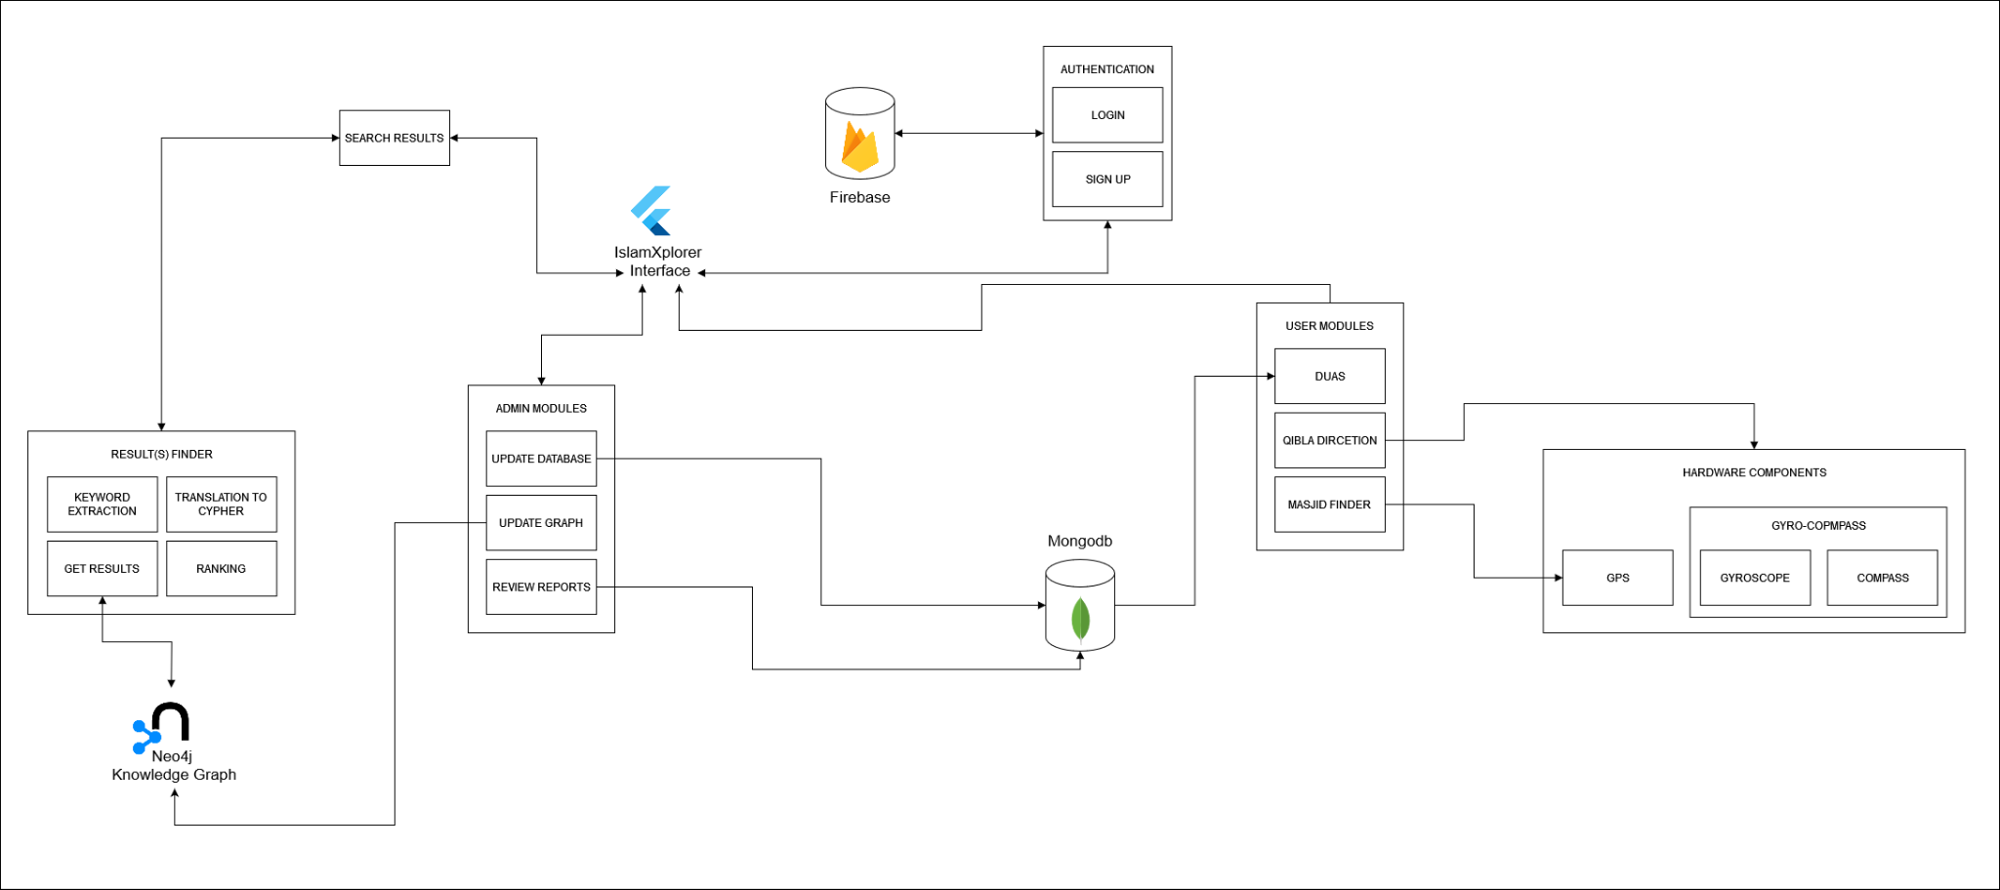

The architectural diagram for IslamXplorer integrates Neo4j for the Knowledge Graph, MongoDB for supplementary data, Firebase for secure authentication, and a Flask API for seamless communication between these components. The Flutter framework is employed for the frontend, ensuring a consistent and engaging user experience across different platforms. This cohesive architecture establishes a robust system where each component plays a specific role, enabling efficient data management, secure access, and an intuitive user interface for an enriched Islamic knowledge exploration.

4.3 **Detailed Design**

4.3.1 **Use Case Diagram (User)**

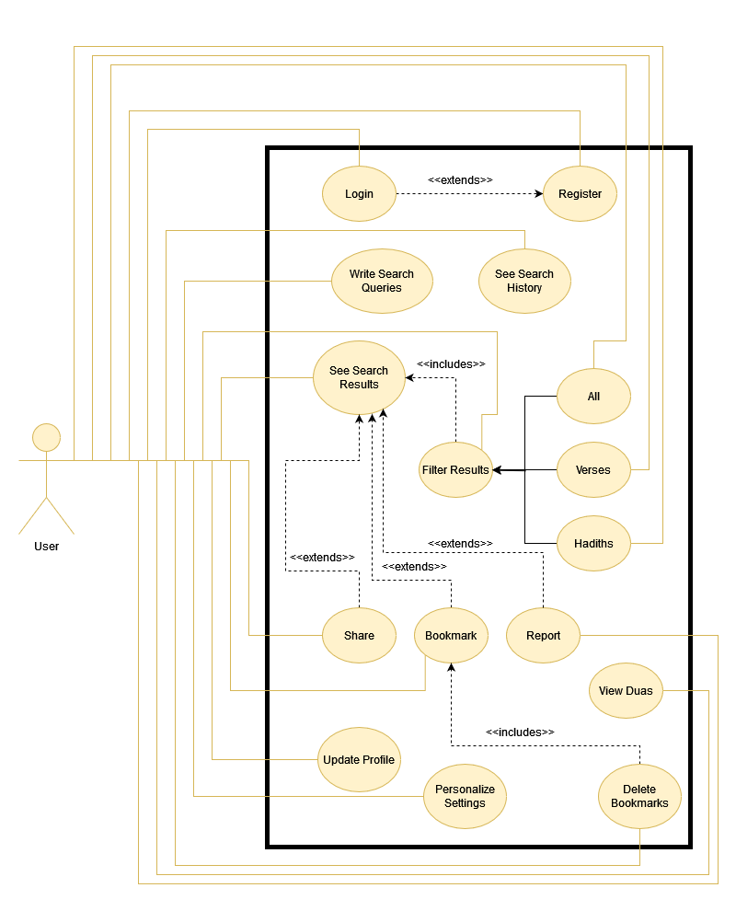

4.3.1.3 **Use Case Description (UC-U03)**

| UC ID | UC-U03 |
| --- | --- |
| UC Name | Write Search Queries |
| Primary Actor | User |
| Pre-Condition | User should have successfully opened the application |
| Post-Condition | User’s search query will be successfully sent to the API |
| Main Flow | 1. The User will click on the Search Bar 2. They will write any type of Search Query in the Search Bar 3. Their previous Search history will be available just below the Search Bar 4. After writing the Search Query, they will press the search icon (or press enter) 5. This will send the User's search query for further processing 6. User will be navigated to the results page |
| Alternate Flow | 1.1 If a problem occurs with the UI, then the Search Bar will not open  1.2 The application will display a crash message, and it will ask the user to try again  3.1 User can click on their previous searched query from the available list  3.2 The query will appear on the Search Bar  3.3 They can then press the search icon to search for the query  5.1 If there is any connectivity issue, the user will be shown with appropriate message  5.2 If there's no internet connection, User will be shown “No Internet Connection” message  5.3 If the Server is down, or is overloaded, the User will be shown a “Sorry, We are at MAX Limit at this time” message  5.4 They will be redirected to the message screen, and will be asked to try again |

4.3.1.4 **Use Case Description (UC-U04)**

| UC ID | UC-U04 |
| --- | --- |
| UC Name | See Search Results |
| Primary Actor | User |
| Pre-Condition | User should have successfully written a Search Query |
| Post-Condition | User will have successfully opened a Search Result to see it's details |
| Main Flow | 1. User will be shown with list of search results retrieved from the server 2. These results will include Verses, Hadiths, Surahs, and Google Search Results 3. User can click on any of the Search Result to see it's details 4. When an item is clicked, User will be navigated to the Details Page 5. All details of the item (Verse/ Hadith / Surah), that are available, will be displayed on the page 6. User can also go back to open another item |
| Alternate Flow | 1.1 If there are no results available, User will be shown a “No Results Available” message  1.2 User will be asked to try again(i.e. to write another search query and try searching again)  2.1 The results may or may not contain all the mentioned type of items  2.2 The results can have any mixture of items that are displayed  2.3 User can click on any type of Item, to see it's details  4.1 If a Google Search Result Item is clicked, the User will be redirected (with message)  4.2 This item will be opened in the browser (of User's choice)  4.3 The user can come back to the application to open any other result item |

4.3.1.5 **Use Case Description (UC-U05)**

| UC ID | UC-U05 |
| --- | --- |
| UC Name | See Search History |
| Primary Actor | User |
| Pre-Condition | User should have clicked on the Search Bar/ or they should have openee Search History Page |
| Post-Condition | User will have successfully manipulated the Search History |
| Main Flow | 1. When User clicks on the Search Bar, they will be shown with their recent search history 2. If the user clicks on an item in the search history, it will appear in the Search Bar, and User can search it 3. If the User long presses the item, they will be prompted with a message “This Item will be Deleted from History” 4. If user clicks “Delete”, the item will be removed from their history |
| Alternate Flow | 1.1 The User can also go to the Profile Page to see their Search History  1.2 User will click on the “See History” button to open the Search History Page  1.3. The User will be shown their Search History in a chronological manner  1.4 If the User clicks on item, it will be searched, taking the user to its particular results  1.5 The user can also press the trash icon to delete the particular item  1.6 The user can also click on “Delete All” to clear their Search History |

4.3.1.6 **Use Case Description (UC-U06)**

| UC ID | UC-U06 |
| --- | --- |
| UC Name | Filter Search Results |
| Primary Actor | User |
| Pre-Condition | Search results based on user's search query should be available |
| Post-Condition | User will successfully see filtered items based on a filter value |
| Main Flow | 1. Filter options will be available on the top, just above the results 2. It's values will be All, Verses and Hadith 3. User can click on any value that they want 4. Based on the specific value, the search results will be filtered 5. And they will be shown again to the user 6. User can filter the results as many times as they like 7. The original results will be filtered every time the user selects a filter value |
| Alternate Flow | 1.1 If there are no results available, User not be shown any filter values  1.2 User will be asked to try again(i.e. to write another search query and try searching again)  2.1 The filter items can be more or less depending on the type of the results that are received  2.2 If the results do not contain verses or hadiths, that particular filter value may not be shown  2.3 If the results contain external redirecting results, it may be an extra filter value that may appear as well  6.1 The origins search query results will be stored in the Phone Cache  6.2 Internet Connectivity will not be an issue |

4.3.1.7 **Use Case Description (UC-U07)**

| UC ID | UC-U07 |
| --- | --- |
| UC Name | Filter All |
| Primary Actor | User |
| Pre-Condition | User should have successfully written a Search Query and have the results |
| Post-Condition | User will successfully see all the results that are available |
| Main Flow | 1. By default, ALL the search results will be shown on the screen 2. These search results may include Verses, Hadiths, and redirecting results 3. If the user is on any other filter option, he may click on the ‘All’ option 4. When user clicks on the ‘All’ option, the original list of results will be shown 5. This list will be stored in Cache, so they will not be called through Network |
| Alternate Flow | 3.1 If the user is on ‘All’ option, and they click on the ‘All’ option, there will be no change  3.2 User will have to click on any other filter option to see the effects of the All option |

4.3.1.8 **Use Case Description (UC-U08)**

| UC ID | UC-U08 |
| --- | --- |
| UC Name | Filter Verses |
| Primary Actor | User |
| Pre-Condition | User should have successfully written a Search Query and have the results |
| Post-Condition | User will successfully see the Verses results that are available |
| Main Flow | * By default, All the search results will be shown * User will click on the Verse option from the filter values * All the results, that are verses, will be shown * Only the verses will be shown to the user, no matter how many they are * User will be able to go back to see All the results, by clicking on the All option * By clicking on any Verse Search Result, the item will be opened to show it's details |
| Alternate Flow | 3.1 The original (all) results will be filtered  3.2 The original results will still remain in the Cache. They will not be deleted  3.3 If the user wants to choose any other filter option, the original list will be used for this purpose again |

4.3.1.9 **Use Case Description (UC-U09)**

| UC ID | UC-U09 |
| --- | --- |
| UC Name | Filter Hadiths |
| Primary Actor | User |
| Pre-Condition | User should have successfully written a Search Query and have the results |
| Post-Condition | User will successfully see the Hadiths results that are available |
| Main Flow | 1. By default, All the search results will be shown 2. User will click on the Hadith option from the filter values 3. All the results, that are hadiths, will be shown 4. Only the hadiths will be shown to the user, no matter how many they are 5. User will be able to go back to see All the results, by clicking on the All option 6. By clicking on any Hadith Search Result, the item will be opened to show it's details |
| Alternate Flow | 3.1 The original (all) results will be filtered  3.2 The original results will still remain in the Cache. They will not be deleted  3.3 If the user wants to choose any other filter option, the original list will be used for this purpose again |

4.3.1.10 **Use Case Description (UC-U10)**

| UC ID | UC-U10 |
| --- | --- |
| UC Name | Share |
| Primary Actor | User |
| Pre-Condition | User should have successfully opened an item |
| Post-Condition | User will have successfully shared the opened item's content |
| Main Flow | 1. User will click on the share option that will be available below the original text 2. Users can share any item (Verse, Hadith, Dua, etc.) 3. When they click on the share option, they will be promoted to select the desired platform 4. The original text (Arabic Text) and the English Text (or any other language Text that the user has selected), with some supporting details, will be shared on the user selected platform 5. After the texts, there will also be a link for IslamXplorer, that will open the app (or take the user to the Play store) |
| Alternate Flow | 3.1 If there are internet issues, the selected platform will not open  3.2 User will be shown with an appropriate message that the item cannot be shared at the moment  3.3 The user will be asked to try again  4.1 The Arabic Text will be stored in Unicode  4.2 If the certain platform doesn't accept Unicode, user will be shown an error message  5.1 The link will be appended with the texts at the very top  5.2 The link will open IslamXplorar (if it is already installed)  5.3 If it is not installed, the link will take the User to play store to download the app |

4.3.1.11 **Use Case Description (UC-U11)**

| UC ID | UC-U11 |
| --- | --- |
| UC Name | Bookmark |
| Primary Actor | User |
| Pre-Condition | User should have successfully opened an item |
| Post-Condition | User will successfully bookmark the opened item |
| Main Flow | 1. The User will open their desired item (Verse, Hadith, Dua, etc) 2. They will then click on the Bookmark button just below the Original text 3. When the user clicks on the button, they will be shown a message that the item has been successfully Bookmarked 4. If the user clicks on the bookmark button again 5. That particular item will be removed from Bookmarks, and user will be shown a message that the item has been successfully removed from Bookmarks |
| Alternate Flow | 3.1 If there is Internet Connectivity Issue, the bookmark feature will not work  3.2 The user will be shown a message there is No Internet Connection  3.3 The User will be asked to try again |

4.3.1.12 **Use Case Description (UC-U12)**

| UC ID | UC-U12 |
| --- | --- |
| UC Name | View Duas |
| Primary Actor | User |
| Pre-Condition | User should have successfully opened the Dua Page |
| Post-Condition | User will successfully any Dua item that is available |
| Main Flow | 1. User will navigate to the Dua Page 2. User will be shown the different types of Duas that are available (Quranic Duas and Hadith Duas) 3. User can select any option they like 4. The User will be again shown the different types of Duas available in that particular section 5. On clicking the desired type option, User will be shown the Duas (with their titles), that are available for that type 6. User can click on Dua that they wish to read about 7. On clicking of a Dua item, it's details will be shown to the User 8. They can go back and select any other Dua to see it's details as well |
| Alternate Flow | 4.1 If there is Internet Connectivity Issues, the User will not be shown the different types of Dua for a section  4.2 The user will be shown an error message, and will be asked to try again |

4.3.1.13 **Use Case Description (UC-U13)**

| UC ID | UC-U13 |
| --- | --- |
| UC Name | Delete Bookmarks |
| Primary Actor | User |
| Pre-Condition | User should have successfully opened the Profile Page |
| Post-Condition | User will have successfully deleted a Bookmark or all Bookmarks |
| Main Flow | 1. User will open the Profile Page, and click on Bookmarks 2. A list of all the Bookmarked Verses, Hadiths, Duas, etc. will be shown to the user 3. User can press the Bookmark, and it will open the item to show it's details 4. User can press the trash icon next to the item to delete that particular Bookmark 5. User can also press “Delete All” to delete all the items that are bookmarked by User |
| Alternate Flow | 3.1 When User clicks on a Bookmarked Item, it will be opened to show it's details  3.2 If there are connectivity issues, User will be shown a message to Try Again  3.3 If the Bookmarked Item is an external redirecting search item, User will be prompted to select their preferred browser to open the result  5.1 Once User presses “Delete All”, they will be prompted if they are sure they want to Delete All Bookmarks  5.2 If User presses Ok, all their bookmarks will be deleted. This action cannot be undone |

4.3.1.14 **Use Case Description (UC-U14)**

| UC ID | UC-U14 |
| --- | --- |
| UC Name | Report |
| Primary Actor | User |
| Pre-Condition | User should have successfully opened a Search Item |
| Post-Condition | User will have successfully reported the contents of the Search Result |
| Main Flow | 1. User will open any search item that they like 2. If the User thinks that there is any sort of mistake in the Search Result, regarding the texts (original or translations), or there is some sort of irrelevant information or misinformation regarding the search item, they can press the report button 3. The report button will ask the user if they are sure they want to report the item 4. The prompt will also ask if they want to write any additional comments as well 5. Once they click send, that particular search item will be flagged, and it's id, with user's reports will be sent to Admin |
| Alternate Flow | 2.1 The original (Arabic Text) may contain some sort of mistakes (spelling, grammar, etc.)  2.2 The translation can also contain any number of mistakes  2.3 The supporting data such as Surah Name, source ID, verse/ hadith number may contain mistakes  5.1 When the user clicks “Send Report”, the id of search item, and the user profile, both will be sent to the Admin for inspection  5.2 The Admin may see the name and email of the User that has reported the item |

4.3.1.15 **Use Case Description (UC-U15)**

| UC ID | UC-U15 |
| --- | --- |
| UC Name | Update Profile |
| Primary Actor | User |
| Pre-Condition | User should have successfully opened the Profile Page |
| Post-Condition | User will have successfully updated their profile details |
| Main Flow | 1. User will navigate to the Profile Page 2. Users can see their profile info(name, username, email, contact, profile image, etc.) 3. They can click in update profile to change any information that they want 4. The already saved information will be shown in the text fields 5. The User can change them accordingly 6. After they are satisfied with the entered information, they can click on “Save” 7. The new information will be sent to the database to update user profile |
| Alternate Flow | 3.1 User can also click on their profile image to change it  3.2 User will be promoted to click an image through camera or select from gallery  3.3 If camera is selected, the phone front camera will open, and user will be asked to click a photo  3.4 User may change the camera if they wish  3.5 If gallery is selected, the phone’s file explorer will be opened  3.6 User will be then asked to select an image that they want as their profile image  3.7 In either case, the new image will be stored in the database, alongside all the other user information  3.8 User can occasionally change the profile photo as they like |

4.3.2 **Use Case Diagram (Admin)**

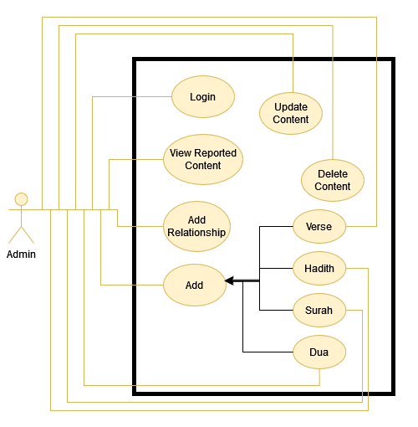

4.3.2.1 **Use Case Description (UC-A01)**

4.3.3 **Sequence Diagram (Search)**

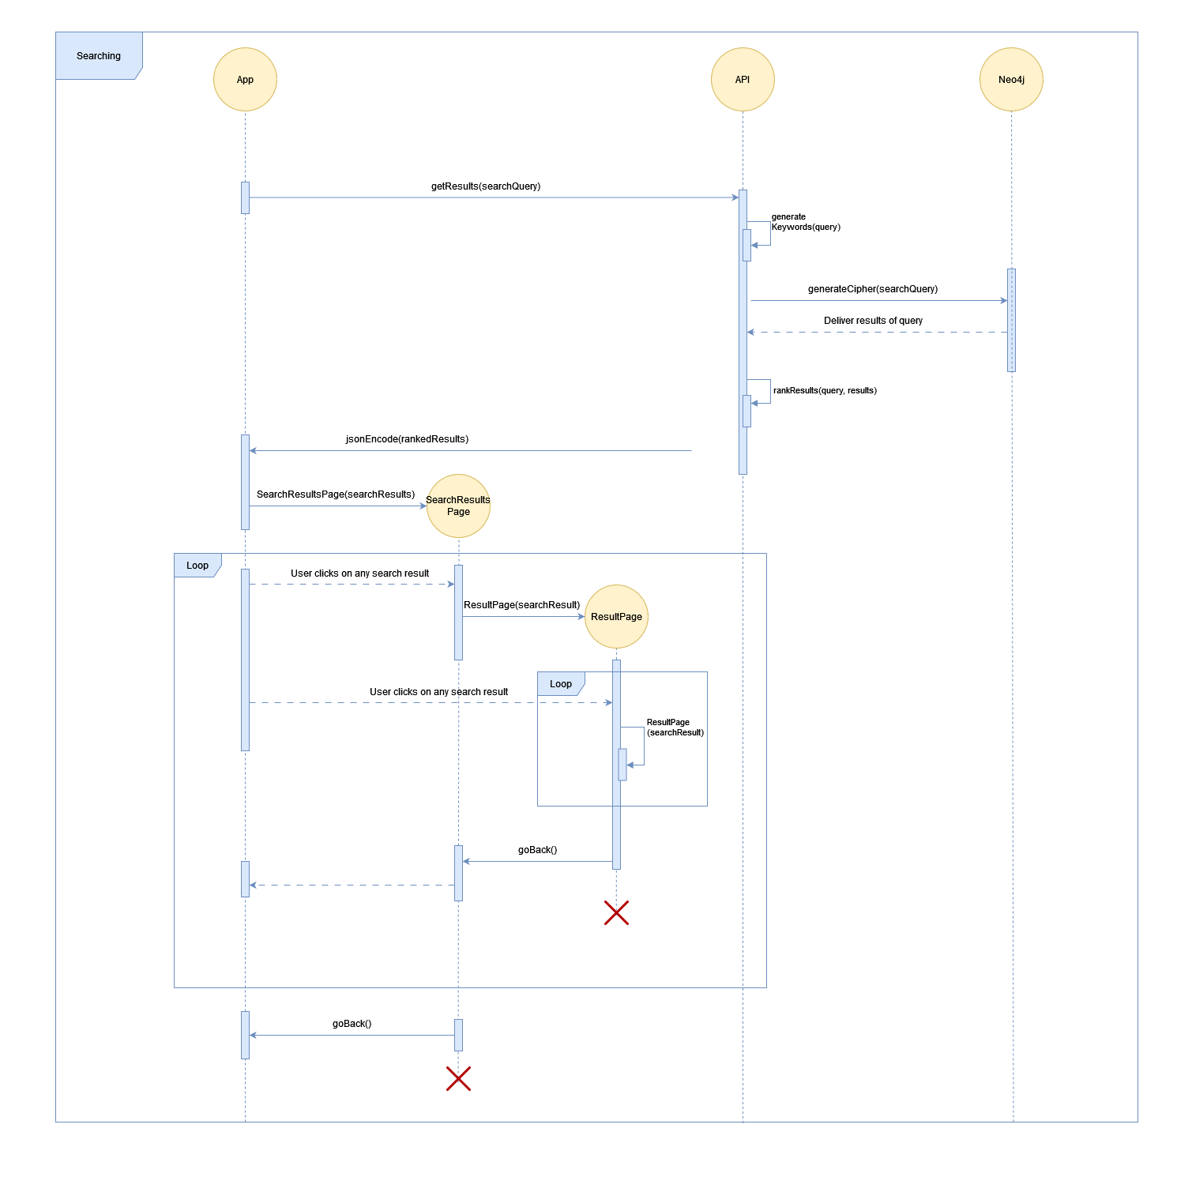

4.3.4 **Sequence Diagram (Add Verse)**

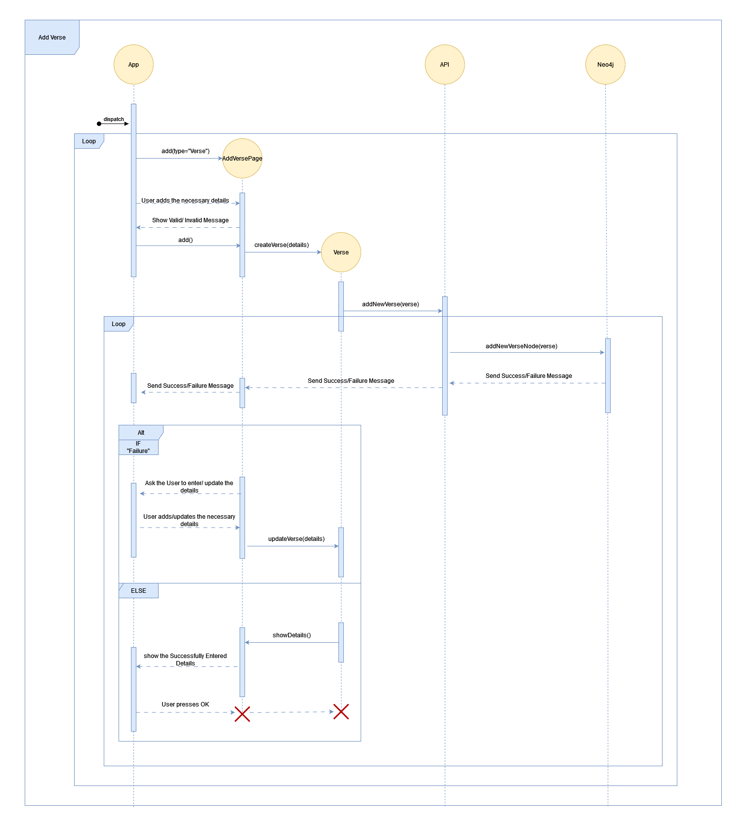

4.3.5 **Sequence Diagram (Add Hadith)**

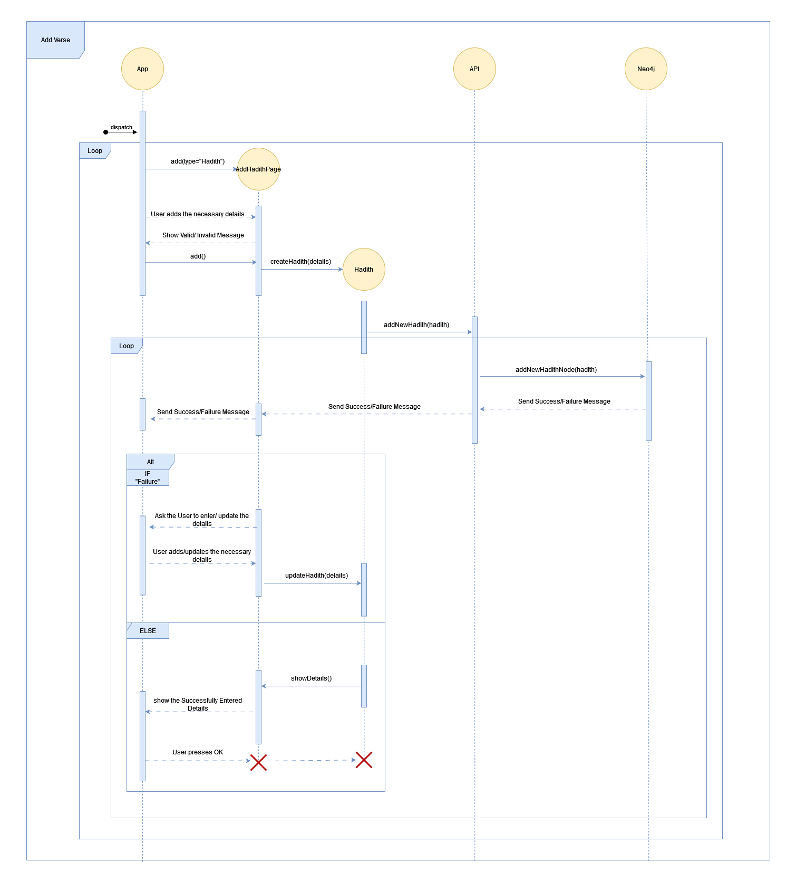

4.3.6 **Sequence Diagram (Add Dua)**

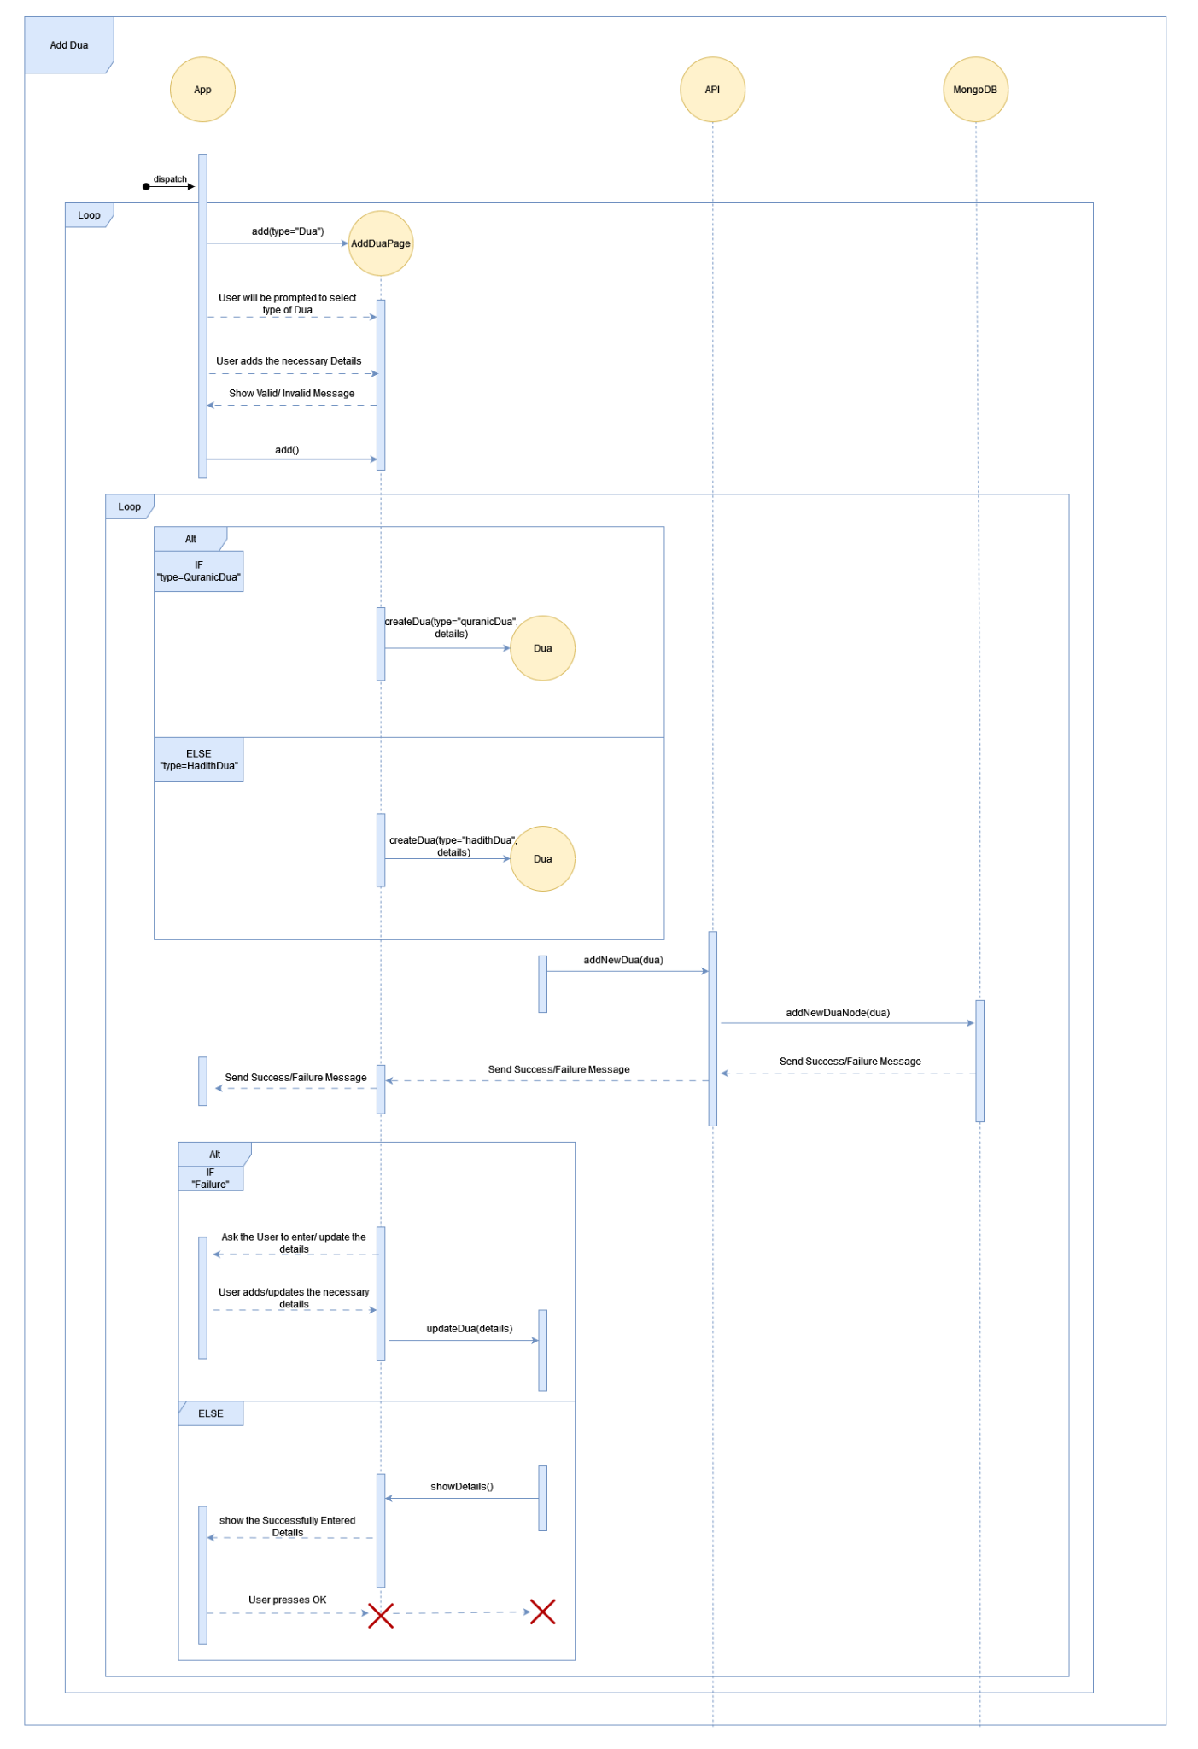

4.3.7 **Class Diagram (Flutter Application)**

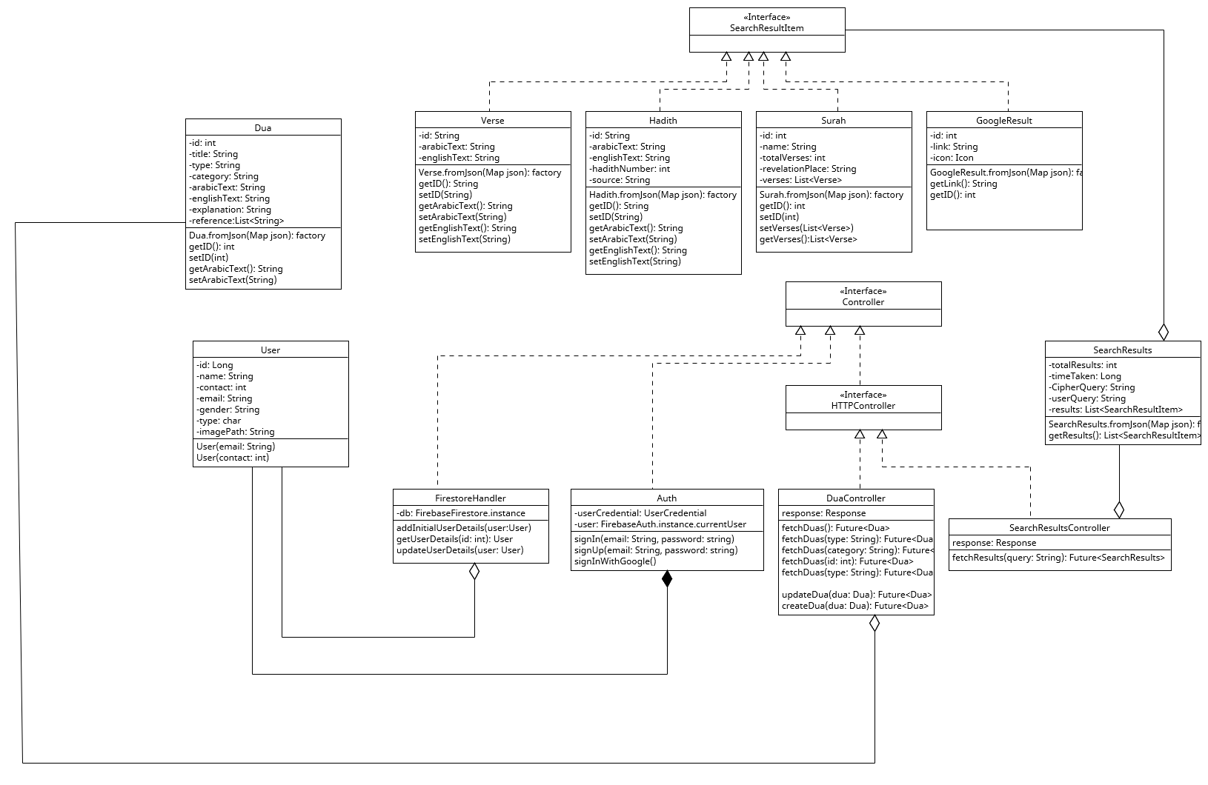

**Chapter 5:**

**Implementation**

**Chapter 5:**

**Implementation**

5.1 **Endeavour (Team + Work + Way of Working)**

5.2 **Flow Control/ Pseudo Code**

5.3 **IDE, Tools, Technologies**

5.4 **Best Practices/ Coding Standards**

5.5 **Development Environment**

5.6 **SQA Activities: Defect Detection**

5.7.1 **Test Case Design (White Box)**

5.8 **Summary**

**Reference and Bibliography**

[1] M. Sher, M. Rehman, “*Title of the Paper*” Conference name/Journal Name, Edition, Volume, Issue, ISBN/ISSN, PP, Publisher/City-Country, Year.

[2] ……

\***Appendix A:**

**Heading (20-Point Size, Times New Roman, Bold)**

Text in 12-Point Size, Times New Roman, 1.5 Line Spacing.

* 1. **First Level heading [14-Point Size, Times New Roman, Bold and left aligned**

Text in 12-Point Size, Times New Roman, 1.5 Line Spacing.

**1.1.1 Second level heading [12-Point Size, Times New Roman, Bold and left aligned]**

Text in 12-Point Size, Times New Roman, 1.5 Line Spacing.